Uncelebrated Lives:
Reflections on the Supporting Player

Dr. Aaron Taylor
Department of New Media
University of Lethbridge
Centre for the Arts W864
4401 University Drive
Lethbridge, Alberta, Canada, T1K 3M4
E-mail: aaron.taylor2@uleth.ca

April 1, 2009

Uncelebrated Lives: Reflections on the Supporting Player

Author:
Dr. Aaron Taylor
Assistant Professor, Department of New Media
University of Lethbridge

Centre for the Arts W864
4401 University Drive
Lethbridge, Alberta, Canada, T1K 3M4
E-mail: aaron.taylor2@uleth.ca

Biographical Note:
Aaron Taylor is an Assistant Professor in the Department of New Media at the University of Lethbridge. His recent publications investigate a number of performative figures in various contexts. These essays appear in The Journal of Film and Video, The Journal of Popular Culture, and the forthcoming American Movie Masculinity and Stages of Reality: Theatricality in Cinema. He is currently co-editing an anthology on screen acting, theory and philosophy.

Abstract:
The essay undertakes an investigation of the concept of the supporting player, identifying the narrational, performative and cultural assumptions that underlie this dramatic category. Disentangling these intertwining constituents reveals certain dominant assertions about cinematic characters and the actors who portray them. Such dramaturgical norms implicitly suppress alternative conceptions of character, performance and narrative engagement. Consequently, the supporting player – as textual function, delimited bundle of traits, social type, performative category and professional designation – will be resituated as an agent that might prompt a contemplative reassessment of a fictional scenario.

The author’s contribution to performance studies is to suggest the means by which a supporting actor’s performative embodiment of a character opens up a textual construction for critical investigation. Supporting players are asserted here as figures that trouble narrative coherence. Rather than limit them to the structural position of an actant that assists or resists a protagonist, the performance of a secondary character can rupture the integrity of a narrative, throwing a story’s explicit concerns into critical relief.

Supporting players are often posited as a mere allies or adversaries, lacking complexity as “flat” characters or types, and their performance style seems devoid of star autonomy. However, they are not simply beholden to the demands of narrative economy, teleology and dramatic coherence. Contrarily, attendance to the minutiae of their gestures can alert viewers to narrative possibilities that transcend actantial functionality. Ultimately the essay demonstrates how an overlooked or “integrated” performance can redirect viewers’ narrative interest toward an associational contemplation of experiences that lie beyond the parameters of the dramatic.

Illustrative Figures

PAGE 2

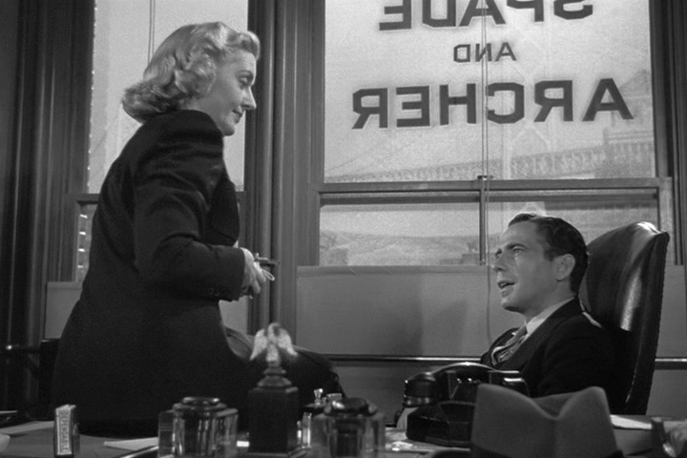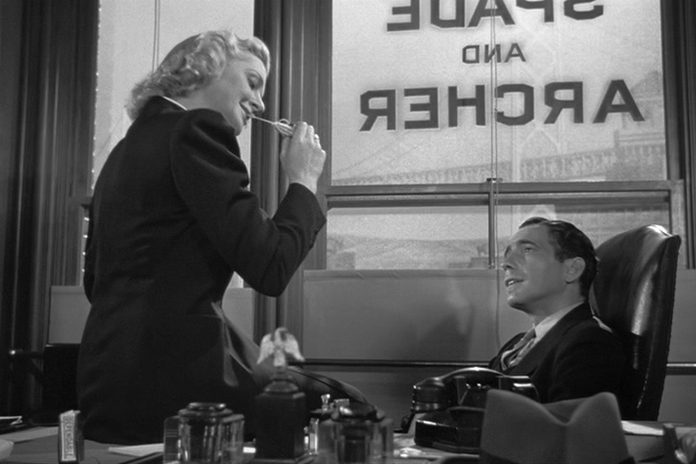
Figure 1.0 Figure 1.1

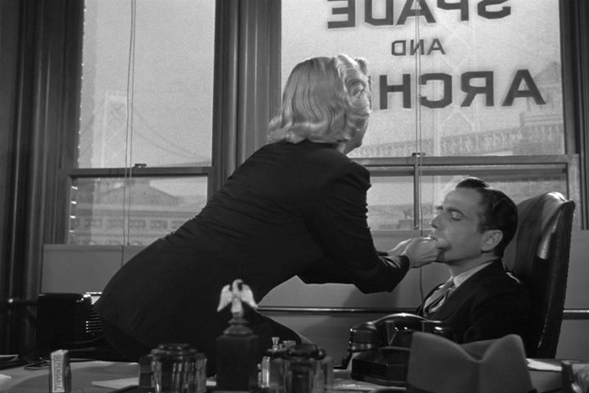
Figure 1.2 Figure 1.3

Illustrative Figures

PAGES 20 – 21

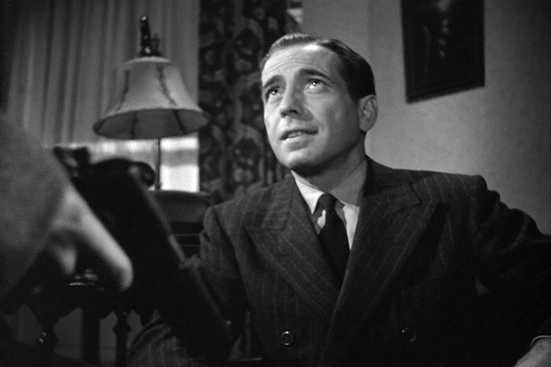
Figure 2.0 Figure 2.1

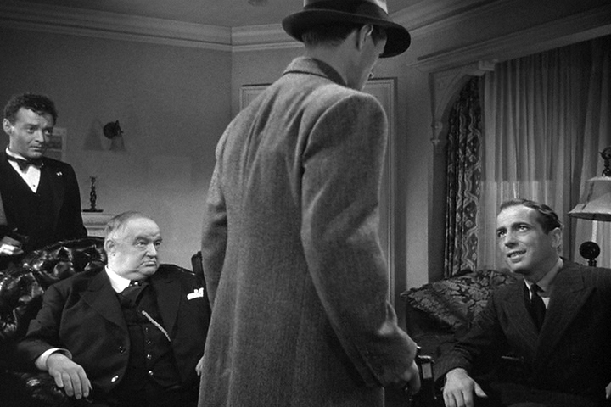
Figure 2.2 Figure 2.3

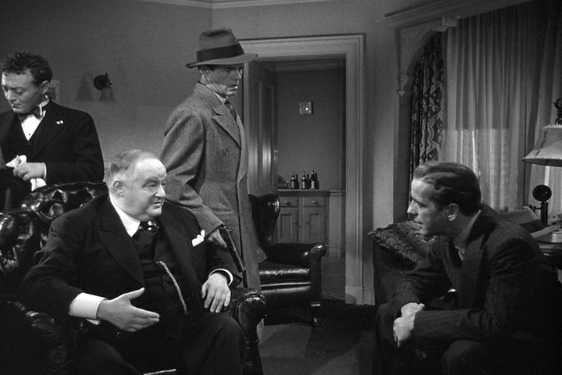
Figure 2.4 Figure 2.5

Illustrative Figures

PAGE 24

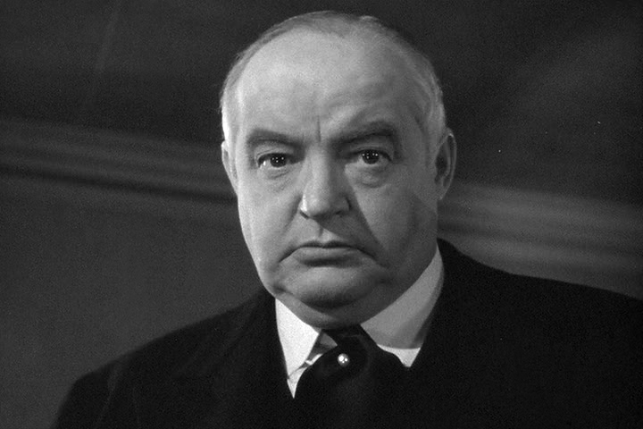

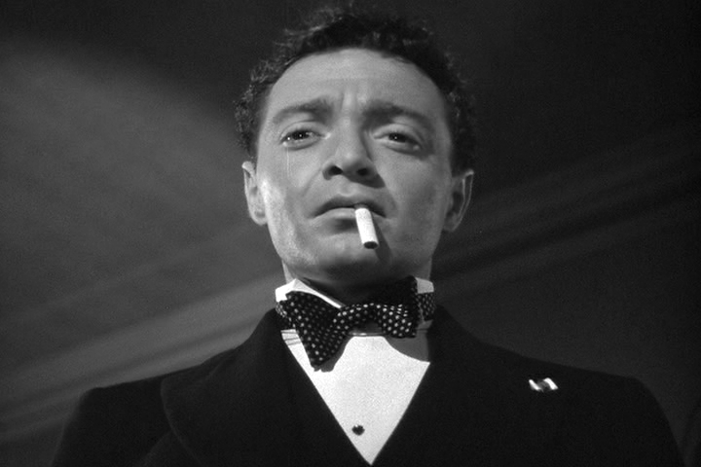

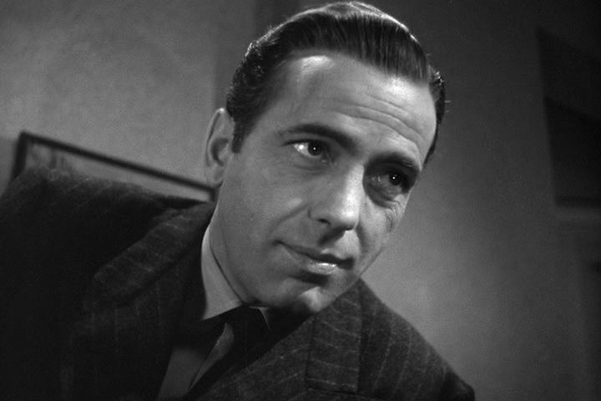


Figure 3

Uncelebrated Lives: Reflections on the Supporting Player

One of the pleasures of viewing a tautly-constructed classical film lies in the potential to discover understated complexity in the most unassuming of sequences. Singling out these moments, or identifying a work that seems particularly adroit in subtlety and nuance is often a rather subjective, even personal, enterprise. Often, it is the performance of a uniquely skilled actor that will retune one’s attention toward the film, directing one toward otherwise overlooked connotations. For me, John Huston’s 1941 version of The Maltese Falcon is just such a film. The performances of its ensemble cast yield suggestive riches with wondrously casual insouciance.
Witness, for example, the brief pas de deux between private investigator, Sam Spade (Humphrey Bogart) and his girl Friday, Effie (Lee Patrick) that occurs fifteen minutes into the film. The motivation of the scene seems straightforwardly functional: we are presented with an opportunity to briefly take stock of the problems facing Spade. He must investigate two murders that the police are anxious to hang on him – Floyd Thursby, a heavy he was hired to tail, and Miles Archer, his own partner – as well as extricate himself from the demands of Miles’ widow, Ida, with whom he had been having an affair.
Curiously, though, I find my attention drawn away from the pressing matters at hand – from speculating about the source of these unfurling conspiratorial tendrils. After all, Thursby is but a murdered name, and will remain disembodied for the entire narrative. Archer is little more than a moustachioed leer, and unlike Spade, my desire to see justice done on his behalf is minimal. As for Spade himself, something distracts me from his plight, in spite of the pleasure I briefly take from the blithe insolence that Bogart brings to the character’s reactionary flippancy. In point of fact, it is the casual intimacy of a series of gestures undertaken by Effie that detracts from the intended narrational focus of the scene.
I note the forthrightness of Lee Patrick’s poise as Effie insinuates herself within Spade’s office, moving with languid familiarity towards his desk, rocking herself up onto it with practiced ease (Figure 1.0); the sensuality with which she dots tobacco onto one of Spade’s rolling papers, cinches the bag shut with small, neat teeth, and passes it to his waiting lips to seal and then accept (Figures 1.1 & 1.2); her winsome readiness with a match as she lights his cigarette even as she offhandedly reveals her discovery of Ida’s recent duplicity (Figure 1.3).
None of these things necessarily speak to the referential meaning of the scene. While the narrative busily sends story threads involving vamps, hoodlums, victims and widows arcing outwards to form its occulted network, my own interest alights upon the beguiling affability of Lee Patrick. I attend to the biting cynicism that was Patrick’s stock and trade during her years at Warners in the 1940s, a sensibility she preserved even after devolving into the matronly socialites she specialized in from the late 1950s onwards. Indeed, there is something of the schoolmarm to Effie, but also an eroticism towards which Sam never directly responds. Her offhanded fussiness co-mingles with half-conscious hints of flirtation, and these have echoes in the more tactical efforts at seduction undertaken by the femme fatale, Brigid O’Shaughnessy (Mary Astor). Not only does Patrick’s performance chime with Astor’s, but her gestures speak towards her character’s submerged but highly meaningful inner life – an interiority we intuit through the enacted suggestions of bemusement, frustration, and longing that Patrick lets slip through Effie’s cozy professionalism.
Of course, her interiority is not the direct concern of the narrative, but Patrick’s characterization of Spade’s indispensable girl Friday is nevertheless instrumental to The Maltese Falcon’s implicit ideas about the persistent maintenance of social performance. I will address these ideas by speaking to the importance of privileging the unacknowledged passions of a film’s secondary characters. That is, I wish to undertake an analytical investigation of the supporting player as a dramaturgical category.
Specifically, I intend to identify and evaluate some of the narrational, performative and cultural assumptions that underlie this classification of performer. By disentangling a number of the intertwining constituents of this categorical position, I hope to reveal certain dominant assertions about cinematic characters and the actors who portray them. I will respond to the situation of the supporting player as a mere ally or adversary, lacking complexity as a “flat” character or “type,” and whose performance lacks what Richard Maltby has described as star “autonomy” (389). More importantly, it shall be determined how these assertions implicitly suppress alternative conceptions of character, performance and narrative engagement.
In part, I have chosen to focus on the supporting actor due to the lion’s share of theoretical attention that stars attract from both cultural studies and the growing number of performance scholars. While the supporting player and character actor have received some attention from a number of notable sources, the performative particularities of the category are generally under-theorized. Instead, discussion surrounding supporting roles has traditionally been relegated to structural narratology, which typically studies the narrative functionality of the character-type rather than attending to the performance itself. My broader interests, then, are to describe the means by which the performative embodiment of a minor character opens up a film for critical investigation. David Thomson has asserted that the “passion” of actors playing small roles makes them “at least as important as any others on view” (32). Appropriately, the figure of the supporting player – as textual function, delimited bundle of traits, social type, performative category and professional designation – will be resituated as an agent that may prompt contemplative reassessments of narrative signification.
The Functionality of Supporting Players
As in any form of social analysis, attending to the structure of specific hierarchies can reveal much about the assumptions behind firmly entrenched institutional formations. The analysis of dramaturgical categories should be no different. As a traditional form of classification, the supporting player is a rather fraught role. By exploring its situation within certain theatrical and literary hierarchies, much can be learned about dramatic structure, casting procedures, performance styles, and presumptions about audiences’ interest in enacted narrative. I do not intend to give a comprehensive account of the supporting player’s historical emergence here, but I do wish to review some of the suppositions that give the role its conceptual coherence.
Historically, the prefixal designation “supporting” has somewhat pejorative connotations. Stemming from the nineteenth century realist conception of character, the supporting role stands in contradistinction to the nuanced psychological complexity of the central character. Classic and oft-discussed literary examples might include Wuthering Heights’ Heathcliff, The Portrait of a Lady’s Isabel Archer and Crime and Punishment’s Rodion Raskolnikov. This novelistic protagonist is notable for his or her particularity, autonomy, roundness and interiority, and it is his or her evolving traits that command narrative attention. That is, a drama will revolve around the developing singular identity of the central character, rather than focus on the social world in which the character is situated. Moreover, the narration’s alignment with the experience of a complex protagonist is said to be complicit with realism’s inherently bourgeois interests: through “identification” with the unique personality of a central character, we potentially overlook his or her normativity, or belongingness to a broader collective. The individual is all.
By contrast, the supporting player is most often a unidimensional type who occupies a decidedly secondary position within the drama. As Richard Dyer points out, this simplistic characterization “is a shared, recognizable and easily grasped image of how people are in society (with collective approval or disapproval built into it)” (47). A type is a kind of an instant character: readily familiar, constant and endowed with very few character traits, most of which are readymade indicators of a preconceived socio-cultural position.
Conceptually, the instant character has a substantial dramatic pedigree. It may be helpful to consider these types as the realist successors of the single-minded characters found in the satirical comedy of humours of the late sixteenth century. In this comic subgenre, an exaggerated trait gives a character a bias in disposition. Such biases have a physiological basis: they are literally attributed to a surplus in one of the four “chief liquids” of the body (blood, phlegm, yellow and black bile) that were thought to determine a predominant temperament (sanguine, phlegmatic, choleric, melancholic, etc.). Such determinism is updated in the late nineteenth and early twentieth centuries in accordance with influential developments in evolutionary theory, physiognomy, sociology and psychiatry. Instant characters are thus driven by equally singular urges, but this time associated with their class, profession, race, ethnicity, and/or environmental situation. Dickens and Austen are the most frequently invoked exemplars of authors whose fictions are peopled by simplistic figures: Hard Times’ pedantic schoolmaster, Gradrind; the faithful Mrs. Micawber in David Copperfield; the ill-tempered Mrs. Ferrars of Sense and Sensibility; Pride and Prejudice’s insufferable snob, Lady Catherine, and so on.
The most famous articulation of this realist structural binary is E. M. Forster’s distinction between “round” and “flat” characters. While the behaviour of the flat character is delimited by a basic conformance or deviation from expectation, the round character stands for the surprising “incalculability of life” (Forster 85). Indeed, the romantic thrust of Jane Austen’s Pride and Prejudice turns on the “incalculable” discovery that Mr. Darcy is not a stuck-up prig at all (unlike the “flatly” snobbish Lady Catherine), but a “roundly” loveable gentleman. By contrast, Forster laments the tedious consistency of flat characters, which he equates with a kind of authorial laziness. “The really flat characters can be expressed in one sentence,” he complains “such as, ‘I will never desert Mr. Micawber.’ There she is, Mrs. Micawber – she says she won’t desert Mr. Micawber, she doesn’t, and there she is” (75).
Consequently, the realist division between psychologically complex, individualistic primary characters and simplistic, socially-oriented secondary characters was readily compatible with typecasting practices undertaken by nineteenth century repertory theatre companies. Indeed, in 1864, theatrical unions such as the American Theatrical Protective association actively campaigned against earlier demands for versatility as a condition of employability. Typecasting took on pragmatic functions, with actors securing specific “lines-of-business” that could be maintained throughout a season. The system was rigidly hierarchical, with supernumeraries (extras without scripted dialogue) at the bottom and leading business (major tragedians, comedians or female stars) at the top. An actor could climb within this hierarchal system depending on his or her suitability to typified roles. Repertory companies, then, would feature a rotation of regular plays enacted by resident players specializing in particular types, with successful performers in possession of – that is, literally owning – their parts.
Pamela Robertson Wojcik has demonstrated how this tradition has been perpetuated throughout the history of American industrial filmmaking, from the stock system of early twentieth century studio bullpens to the self-designated typing of performers in the American Players Directory. Just as studios in the 1920s began to build up “stables” of regular performers associated with readily identifiable types, freelance bit players and extras were hired through the Central Casting Corporation based upon their resemblance to stereotypical embodiments of social categories. In essence, “typing oneself quickly became and continues to be a practical necessity” with would-be actors and casting agencies foregrounding physical appearance and social identity over experience and dramatic range (Wojcik 241). Homologies between roles and appearance become increasingly rigid, and concurrently, more ideologically loaded – hence the typical relegation of actors embodying a certain age, body type, ethnicity or race to subservient roles, or “flat” characters. Stanley Cavell astutely summarizes the implications of this performative caste system: “We were not given, and were not in a position to be given, individualities that projected particular ways of inhabiting a social role; we recognized only the role” (33). Supporting players are not intended to project an individualized style of social being; the privilege of personifying a type is reserved for the central character, for the star.
We can recognize how the polarization of a dramatis personae between psychologically complex, individualistic primary characters and simplistic, socially-oriented secondary characters was readily adopted by the emerging studio system. Most certainly, it gave aesthetic justification to the developing institutional distinctions between “star” and “supporting” types in the late 1910s. Not only are these distinctions reinforced at the contractual level, but in other considerations of an actor’s merit as well. The bifurcated honorarium for performance at the Academy Awards is a good example. Introduced in 1936, the “Best Supporting Actor” award is a decidedly subaltern category delimited by the strictures of corporate pedigree, screen time and structural functionality. Tellingly, recipients of the award were presented with plaques rather than Oscar statuettes until 1943.
Again, at an ideological level, such distinctions between star and supporting types are said to reflect and reinforce a kind of bourgeois humanism. The star is a kind of higher order type – one that either reinforces idealized modes of social organization, or renders them invisible as such. Siegried Kracauer, for example, argues that although both star and supporting types are defined by their physical appearances, the star points toward a distinct individuality rather than a social group, an individuality that is attractive for the “pattern of living he represents or suggests” (100). Moreover, the distinction is also said to reflect the star system’s implicit imbrication with consumer capitalism. In keeping with Kracauer’s realist preoccupations, Rudolf Arnheim contrasts the character actor’s proletarian appeal to the superficiality of the star, whose models of stylization exist “only in the pictorial advertisements of the cosmetic industry” (53). In turn, the mutually beneficial cross-promotional relationships between stars and the corporations for whom they advertise are underwritten by the charismatic singularity of the celebrity actor.
Because the star is a public personality, their performances are correspondingly marked out by what James Naremore describes as a substantial degree of presentational ostentation (22). Star performance transforms the actor into a kind of aesthetic object for our pleasurable contemplation. S/he is not so much a possible person within an enclosed diegetic order, but a highly “visible” presence who offers him/herself up for our scrutiny and appreciation. Stars are said to be diegetically semi-autonomous: by foregrounding their own recognizable persona rather than imitate a fictive other, their performance style is motivated by presentational rather than representational obligations (Maltby 389). In contemporary Hollywood, there is probably no clear-cut example of a male star that more closely conforms to such presentational ostentation than Tom Cruise. His athletic performance as the misogynistic and fraudulent self-help guru, Frank Mackey, in Magnolia (P. T. Anderson, 1999) is particularly instructive in this respect. Despite being part of an ensemble cast, Cruise takes the opportunity to execute a star turn: he explores and showcases his own familiar persona as an assertively macho and charismatic self-promoter, one who might deserve being taken down a peg or two.
Conversely, the supporting player is a “mid-level player, recognizable and associated with a particular line of business, but not ‘known’ as a real or private person” (Wojcik 240). erformance style tends to be driven by mimetic imperatives, the demands of plausibility and a degree of selflessness. Often undertaken by seasoned character actors, or relatively unknown up-and-coming actors, a supporting role will generally give the impression of a credible fictional individual, albeit a “flat” one. Correspondingly, the performance will seem integrated within a naturalistic diegesis from which we are separate (Maltby 381). Supporting players are at the service of the narrative, and therefore, their performance signs are not to eclipse the process of storytelling. We are to recognize the character first, and the performer second – if at all.
We might turn again to Magnolia for an example and note William H. Macy’s role as a washed-up former quiz kid, Donnie Smith. Macy is most often cast in secondary roles that maximize his droopy, hound-dog countenance and used car salesman demeanour, and the earthiness of his characters often serves to ground the ostentation of the star characters against whom he is cast. Aside from his charity work for the United Cerebral Palsy Association, we know little of him as a public figure, but his role in Magnolia quintessentially defines the familiar “Macy” persona: a struggling, put-upon, middle-aged loser whose efforts to better his situation frequently incline toward personal disaster. While Cruise’s back-flipping star performance is highly visible, an apparently autonomous element from the film’s formal system, Macy’s self-deprecating role seems to be much more integrated to the demands of the narrative. Accordingly, reviews of the film typically refer to the reflexive elements of Cruise’s characterization, but mention Macy only in passing as one more battered soul amongst Magnolia’s troubled denizens. Allegedly, we are invited to evaluate Cruise as a performer but recognize Donnie Smith as a character.
In addition to differences in their perceived psychological complexity, industrial positioning, ideological resonance and performative incorporation within a diegesis, leading and supporting players are also set apart by their respective dramatic functions. Such distinctions are made by theorists in both academic and industrial spheres. Specifically, it is the centrality of structural linguistics in film theory and the neo-classicism of professional screenwriting guides and seminars that has indirectly perpetuated this hierarchical divide. Both reinforce the subsidiary function of the supporting player, whose textual role is decidedly ancillary.
On the one hand, early structural narratology proved attractive to politically-minded theorists for its rejection of realism’s humanistic inclinations. It strove to demonstrate how a character was less a “possible person” than a feature of a textual framework. By subordinating character-types to functional “spheres of action,” structuralist theorists insisted on describing characters as actants. An actant occupies a role that is structurally necessary to the integrity of the narrative. Correspondingly, she must embody the traits and perform the actions that her role necessitates. Such structuralist discourse is readily applicable to classical Hollywood narratives, in which the “actantiality” of characters seem particularly pronounced. Key actions in The Wizard of Oz (Victor Fleming, 1939), for example, are performed by a heroine (Dorothy), who is given a task by a dispatcher (the Wizard) and whose ambitions to return home are blocked by an adversary (the Wicked Witch). Instead of engaging in traditional motive-seeking, then, structuralism is interested in how recurrent spheres of action signify within changing contexts. Thus, a character’s actions are evaluated architectonically, rather than moralistically.
On the other hand, however, structuralist discourse had a reductive influence on certain character types. Despite its analytical and political usefulness, this narratological tradition nevertheless minimized the secondary character’s capacity for connotative significancy. Indeed, when considered functionally, these supporting character-types are decidedly subsidiary. A. J. Greimas, for example, relegates the actantial roles of “helpers” and “opponents” to the grammatical status of participles: “they are the circumstantial ‘participants,’” he claims, “and not the true actants of the drama” (84). Returning to our structuralist description of The Wizard of Oz, we note that a few helpers (the Scarecrow, Tin Man and Cowardly Lion) assist the heroine by helping her accomplish her tasks, but their own desires are seen to be structurally extraneous. That is, their respective ambitions for brains, heart and courage are coincidental with Dorothy’s quest, rather than integral to the story. In Seymour Chatman’s terms, the travelling companions’ objectives are “satellites” to the “kernel” of Dorothy’s ambition to return home – their activities would largely be construed as structurally supplemental (53-55). Similarly, Roland Barthes might regard their actions as “catalysers” that serve as the “trivial incidents” between the structurally necessary “cardinal functions” undertaken by the protagonist (“Structural” 94).
A certain congruence exists between structuralist discourse and the industrial practice of classical screenwriting. While not every screenwriting manual follows Aristotelian traditions by insisting on the subservience of characterization to plot, secondary characters are still often regarded as formal devices rather than subjects who might be interesting in their own right. For example, in Story – an influential guide to writing saleable screenplays – Robert McKee’s instructions regarding secondary characters echoes Greimas’ grammatical analogy. He maintains that “the protagonist creates the rest of the cast. All other characters are in a story first and foremost because of the relationship they strike to the protagonist and the way each helps to delineate the dimensions of the protagonist’s complex nature” (379). And because the Hollywood dictums of classical dramatic structure and narrative economy generally do not favour the democratic dispersal of screen time, nor ensemble casts, screenwriting gurus tend to demand an hierarchal dramatis personae. Screenwriter, Syd Field, for example, maintains that only one character should serve as the protagonist – that despite the equal billing of the titular characters in Butch Cassidy and the Sundance Kid (George Roy Hill, 1969), we are to regard the former as the main character, while the latter simply plays second fiddle (26-27).
So, the traditional idea of the supporting player is that of an actor who will represent a more or less unidimensional character, embodying a given social type and whose performance is mimetically integrated within the narrative. Rather than occupying the actantial role of protagonist, s/he will function as an ally or adversary; his or her traits and designated actions are primarily assigned for the purposes of structural reinforcement. In essence, the position is beholden to the demands of narrative economy, teleology and dramatic coherence.

Presumptions and Limitations
Each of the assertions above appear relatively straightforward enough, and their articulation in various academic, industrial and popular discourses is generally received as unproblematic (the waning theoretical influence of structuralism in film studies obviously notwithstanding). And yet, such a construction of the supporting player is symptomatic of certain contentious assumptions about narrative, performativity and spectatorship. In the spirit of constructive scepticism, then, I would like to review briefly some of these presumptions, and from there, offer a number of theoretical correctives. For some, my remedial suggestions may seem analogous to certain post-structural emphases on textual indeterminacy and playfulness. However, I do not wish to replicate nor endorse familiar post-structuralist attitudes towards character and performativity here. Rather, I prefer that my conjectures might emblematise the reception experience of viewers untrained in the intricacies of Continental theory instead. That is, I believe that there are productive connections to be made between an attentiveness to the supporting player and the associational quality of ordinary spectatorship.
The first presumption about supporting players involves a viewer’s interest and receptivity to characters. We recall that supporting players are thought to embody “flat” or instant fictional persons. What must be pointed out is that by perpetuating variations on Forster’s round/flat binary, only certain characters manifest will ever manifest a “complexity” worthy of our interest and sympathetic engagements. The “novelistic” protagonist maintains his or her centrality by monopolizing particularity, autonomy, roundness and interiority. Lacking these qualities, secondary characters rarely command prolonged narrative attention. In Notting Hill (Roger Michell, 1999), for example, it is William Thacker’s (Hugh Grant) romantic exploits that attract our investment in the film and not the artistic desires of his eccentric Welsh roommate, Spike (Rhys Ifans). Devoting more screen time to Spike is not just structurally impossible; rather, his transparency and simplicity is implicitly deemed beneath our sustained interest.
The second presumption involves the functionality of the supporting player and the perceived structural integrity of narratives that such figures reinforce. We have seen how supporting players are regarded as structurally significant only insofar as they modify or flesh out the traits and corresponding actions of the protagonist. However, by investing in bifurcated actantial categories and the participality of secondary characters, one assumes that narratives are self-enclosed signifying systems. Represented events within these systems only acquire relevant meaning in relation to the structuring imperatives of a central protagonist. For example, it is presumed that the key actions of Paul Newman’s persecuted jailbird as he strives to retain dignity in the face of inhuman conditions form the only relevant narrative “kernels” of Cool Hand Luke (Stuart Rosenberg, 1967). But such an account overlooks our attentiveness to the experience of other inmates. It does not anticipate how our imaginative contemplation of Dragline’s (George Kennedy) predicament might disrupt the orbit of this “satellite,” and how this disruption might in turn expand the strictures of Luke’s more immediate, pertinent story.
The third presumption involves the supporting player’s foregrounded typicality. Unlike the star/protagonist who individualizes the conventional type to which s/he belongs, we are to recognize the supporting player as an exemplar of the type itself. But by reserving the privileged status of “individuality” for central characters, one tends to overlook the protagonist’s membership within a larger social category. We are asked to disregard the fact that John Wayne’s Ringo Kid is just another Western cowpoke in Stagecoach (John Ford, 1939), for example, while investing in the racist reduction of Geronimo and his Apache warriors to anonymous marauders. Stressing the conventionality of the supporting player discounts the inherent typicality of all fictional characters and the performers who actualize them.
The final presumption involves the performance style associated with the supporting player and our apprehension of their acting as such. Because their actantial functionality is subsidiary, the types usually played by character actors are less likely to be represented with the ostentation and autonomy that a star exhibits. Implicit in the description of supporting performance styles as representational and diegetically integrated is the assumption that our attention to supporting players is narratively motivated. We will only be interested in the irritable housekeepers played by Thelma Ritter, for example, for the way in which they sardonically criticize the main characters’ desires and objectives. While we may admire her no-nonsense attitude toward Jimmy Stewart’s lack of commitment to Grace Kelly in Rear Window (Alfred Hitchcock, 1954), her character’s own unseen private life is of no relevance to our comprehension of the film’s narrative. Thus, by relegating ostensive performativity to autonomous star performances, the apparently transparent and integrated performance of the supporting player is chained to the narrative’s referential meanings.
In sum, by conceptually subjecting the supporting player to the demands of narrative economy, teleology, diegetic absorption and dramatic coherence, one implicitly constructs a totalised subject position for viewers. That is, traditional characterizations of the supporting player consign a viewer’s engagement with characters and performers to the more or less purely cognitive activity of comprehension: the construal of referential and/or explicit meaning. We simply observe how his or her actions might influence narrative progression, the impact s/he might have upon the structuring desires of the protagonist, his or her intensification or diminution of teleological edicts, and so on.
This traditional conception of the supporting player as a “minor role” misrepresents the nature of classical narratives, the relationship between performance and story as well as our interest in filmic fictions. Performance often transcends functionality and can provoke meditative wonderment. A noteworthy performance by a supporting actor is not only a creative utterance available for aesthetic appreciation; it opens up the narrative to intriguing potentialities. By singling out moments in which a supporting actor transcends the textual demarcations of her role, one does not endow them with meaning that is an excess of signification and subverts functionality. Rather, their fugitive attractions reveal avenues of experience that are circumvented by the tunnel vision of causality. To borrow from Murray Pomerance, such moments may evoke “something that is not the concern of the story or even of the story-of-the-story but that prods us, announces itself unmistakably as poignant” (114). They can allude to realities that are beneath narrative consequentiality, yet rife with transfiguring potential. In other words, attentiveness to performative nuance may unveil disregarded worlds.
Scene Stealing, Receptivity and Interpretation
Andrew Klevan has voiced his appreciation for “undramatic” qualities of characters’ circumstances that are not of express concern to a narrative’s intentions. His admiration speaks to their submerged personal histories, and he asserts that “the skill of the supporting performer is to suggest the story of a life through pieces” (88). However, I do not consider these undisclosed stories to be supplementary, nor simply a means of thickening an insubstantial narrative. Rather, the performance of a supporting player may actively trouble narrative coherence. By offering disruptively expressive moments that are indicative of structurally irrelevant desires, these actors can rupture a story’s integrity. More importantly, they can provide viewers with unique means of throwing referential meaning into critical relief.
A useful way to conceptualise these productive ruptures is to first consider the relationship between actor and character in a way that allows for the creative participation or intervention of the viewer. Cynthia Baron interestingly conceives of an actor as “a kind of prism through which a character is refracted” (40). A mediated performance, then photographically reconstitutes an actor’s embodiment of a more or less pre-scripted fictional subject. Prior to filming, recording or rendering, this subject – which we could also call a character, or “possible person” – is a pre-given and latent totality that awaits actualization by a performer. It is the responsibility of the performer to concretize this possible person for us, to realize and solidify them as a subject rather than a mental concept or textual construct. S/he will do so by identifying, analysing and interpreting what she considers to be the core elements comprising the subject’s latent personality.
Not only is this the kind of interpretive textual analysis with which most of us are familiar, it is also a creative process as the actor (or programmers and animators in some cases) begins to formulate the expressive decisions that will physically (or virtually) articulate her ideas. During the course of a performance, then, an actor will make the latent totality of a scripted character manifest. She will do so by reconfiguring this atomised character through the twin filters of her own interpretive intelligence and expressive body. This creative embodiment is a necessary textual feature – she actualises a character existing within a diegesis – and is also an expressive construct worthy of our critical attention and aesthetic evaluation in its own right.
A mediated performance, then, is a doubled act of reconstruction. An actor will interpretively reassemble a textual character through his or her performance. Crucially, these reconfigurations are in turn reconstituted by viewers during the process of reception. In turning our attention to an actor’s performance as such, we not only progressively synthesize an idea of the character they portray, but we assess their capacity for narrative signification. Moreover, it is not simply the character’s actions, words and behaviour that signify; an attentive viewer also attends to the actor’s “particular way of inhabiting a social role.” Paul McDonald persuasively argues that an actor’s minute expressive decisions will affect audience interpretation – not just of the character, but of the film’s significance as a whole (28). If this is true, then a supporting player’s ability to contribute to a film’s implicit meaning far outweighs his or her limited capacities in the realm of referential meaning.
The implicit meaning that I have in mind here is not precisely subtextual – an idea only hinted at through connotation or metaphor. We do not use the supporting player as a conduit for occulted and subversive suggestions, as Robin Wood uses Janet Shaw in his interpretive reading of Shadow of a Doubt (Alfred Hitchcock, 1943). For him, Shaw’s beleaguered waitress, Louise serves as the “alter ego” of the heroine, Charlie (Teresa Wright). Charlie’s encounter with her former classmate, Louise, in the “disturbing” Til Two bar sequence is a privileged moment for suggestively revealing the two interdependent sides of American capitalism: splendour and wholesomeness vs. deprivation and corruption (49). And yet, Wood pays no attention to how Shaw herself might help one uncover this covert idea, nor does he note how her performance can address the more explicit complexities of the story’s content. Similarly, the supporting player is not the royal road to some kind of Machereyan “unsaid” that the text itself represses; again, they articulate nuanced ideas visibly through an embodied expressivity.
Rather than describing interpretation as a search for subtextual or covert meanings, we can describe our responses to the work of supporting players as a kind of cognitive shift. In essence, they can provide us with a way of altering our comprehension of the narrative’s surface action. We no longer rely upon them for our construal of referential meaning (simply “following” a story) or explicit meaning (understanding a story’s “message”); instead, they prompt us to identify the energies, tensions, complexes, feelings, impulses and so on that animate a story, giving it weight, breadth, life. A supporting performance bespeaks something akin to Barthes’ “third meaning.” As the issue of “a structuration which leaks from inside,” performative details exceed immediate narrative functionality and move us beyond a story’s purposive narrativity to its animus (Barthes, “Third” 58). In another consideration of Shaw’s appearance in Shadow of a Doubt, Murray Pomerance offers a similar Barthesian outlook on the cognitive activity her performance inspires. She is a punctum to the narrative’s studium – an obstruction, or rupture in the story’s evidentiary capacity that demands reflection as a way of coming to terms with our own relationship with the film (Barthes, “Reflections” 26-27). Turning our speculative attention toward her, we are offered a new, disruptive point of view on the film’s proceedings. This is not simply an alternative perspective, but “a point of concentration of narrative and focal intensity” – one that reveals the very need that lies behind the narrative system (Pomerance 114).
What must be stressed is that the interpretive activity that a supporting performance prompts is not a matter of decoding symptomatic meanings, nor responding to narrational cues; it is a fundamentally associational enterprise. We can derive intensely personal connotations from a gesture, flourish, or turn of phrase (they might remind us of this or that intimate acquaintance or memorable occasion). Taken by surprise by compacted complexity, and hungry for further knowledge, we might construct elaborate speculative biographies for their characters. Most poignantly of all, we might be inspired to imagine how his or her overlooked story spills beyond the diegetic order, how his or reality extends the limits of narrative structure. Indeed, imaginatively expanding a diegetic world to encompass the unrepresented experiences of a supporting player can inspire a reconsideration of what we take to be the film’s concerns, or more introspectively, our own needs in attending to these concerns. S/he can remind us of how our actual reception of a film is often beyond discipline. Despite neoformalism’s construal of stylistic choices as cues that invite ideal responses, or the semiotic interpretation of a filmic text as a network of codes in need of decipherment, there is always a wildness to one’s engagement with film. To be willingly caught up in a supporting player’s unseen world, then, is an unruly act of creative embroilment. This is not to shy away from “subjective” or “associational” responses, but to allow them latitude in shaping a sophisticated interpretation of a film’s implicit ideas.
Returning to The Maltese Falcon, then, an extraordinary moment in Elisha Cook Jr.’s performance provides a compelling illustration of an actor’s ability to stimulate our responsiveness to a film. Cook plays a hired gun, Wilmer Cook, who proves to be thoroughly inept at his chosen profession. His attempts to shadow Sam Spade are frequently foiled by Spade himself, and he is continually on the receiving end of the detective’s barbed witticisms. The moment in question occurs during a sequence in which Wilmer’s boss, arch-criminal Kasper Gutman (Sydney Greenstreet), attempts to negotiate with Spade for the possession of a valuable statuette that he and his viperous consortium have been pursuing. In return, Spade demands a fall guy who will take the rap for the murders of Archer, Thursby, and the statuette’s courier, Captain Jacobi. The trigger-happy Wilmer appears to be the most likely candidate for this role.
There is an extraordinary emotional turn during this six shot sequence, with Elisha Cook expressing a sudden breakdown in Wilmer’s meticulously cultivated self-identity. In the first shot, there is a slight tilt up and push-in from medium close-up to close-up as Wilmer takes two heavy steps forward, eyes widening and jaw slackening – a study in barely contained fury (Figure 2.0). Understandably, Spade draws backward in the reverse shot. Seated, he is forced to look up at this livid little gunsel, and he warily maintains eye contact as Wilmer’s gun hand enters the foreground (Figure 2.1). Spade’s bemusement now seems forced and does not quite mask his suddenly cautious apprehension. In the cut back to Wilmer, the young tough’s eyes are glistening, and his strangled challenge to Spade, “Get up on your feet,” is barely audible. Shockingly, tears begin to well up in his eyes, and a dramatic shift takes place in our initial reading of his emotion as murderous anger (Figure 2.2). Viewed from the position of Spade’s discerning gaze, a dawning recognition emerges that Wilmer is fundamentally out of his element.
His emotions nakedly on display, this secondary character is now quite literally the centre of attention: in the fourth shot, he is isolated in the middle of the room, flanked by a now-amused Spade, a worried-looking Gutman and his nervous associate, Joel Cairo (Peter Lorre) (Figure 2.3). Wilmer’s vulnerability is now masked from our view, as Spade instructs Gutman to defuse the situation in the interests of business. Ever the paternalist, Gutman reprimands his charge with a gentle, “Now, now, Wilmer.” His admonition is almost tender: “You shouldn’t let yourself attach so much importance to these things,” – a fatherly lesson in the necessity of maintaining a glib front. But this little boy is nearly beyond restraint. A return to the previous close-up reveals his stricken, wild eyes and the tears that are now visibly running down his cheeks (Figure 2.4). The violent emphasis on his mumbled reply, “Then tell him to lay off me, then,” is not so much a threat as it is a plea, exposing his total dependency on his patron’s tolerance and authority.
In the final shot, he is summarily ushered off center stage, subordinated once again, as if being condemned to stand in the corner. With a slightly more emphatic, “Now, Wilmer,” and two sharp tugs on his sleeve, Gutman pulls his unruly child to his side. Withstanding Spade’s condescending grin, Wilmer keeps his wild eyes locked upon his persecutor as he brushes past him, one finger still looped threateningly within his pistol’s trigger guard (Figure 2.5).
What is shocking here is that for the first time in this hard-boiled world, excessive and genuine emotion is on display. Prior to this moment, character behaviour is determined by a scrupulous adherence to public role-playing: everyone continually performs as a type – or cannily shifts between stock roles – in order to achieve material objectives. Indeed, the hard-boiled crime film hyperbolically insists on the necessity of a meticulously-cultivated persona as a condition of survival itself. Consequently, authentic emotion is shunned as a sign of weakness and intimacy is avoided due to its unmanageability. As a protagonist, Spade’s agency and power is derived from his ability to sift through the layers of others’ purposeful performances. This intuitive discernment allows him to cannily manipulate others for his own purposes. Thus, it is not just a matter of narrative interest that interiority is figured as taboo – the generically necessary withholding of motivation for the purposes of suspense. Characters perform in a manner that deliberately attempts to obliterate signs of interiority, especially since any genuine emotion could be used against them by others. Indeed, authenticity of feeling is explicitly equated with “sappiness” by Spade himself during his final moments with O’Shaughnessy.
Wilmer is revealed here as a sensitive and vulnerable boy who cannot convincingly portray his idealised type – the menacing tough. If his tears are somewhat shocking, it is because they are incommensurable with the hardened surfaces we have come to expect of these characters. But Cook’s performance here is truly noteworthy because it is also indicative of another order of experience denied by the consensual world of hard-boiled performances. Genuine feeling is unseemly – something from which to recoil as Spade does – because it is a marker of an unacceptable authenticity.
The motivations behind Spade’s merciless scorn for Wilmer’s transparency and sensitivity will later become apparent. Earlier, Spade mocks the readiness with which Wilmer draws his guns, deriding him as “young Wild West.” Rashna Wadia emphasises Spade’s recognition of the incommensurability between Wilmer’s self-styled role and the situations in which he tries to mobilize this act. “As the gun-slinging cowboy who is displaced from but still living in the West,” she claims, “Wilmer’s act can be seen, as Spade does, as Camp” (191). But Spade’s ridicule is not a simple measure of noting the disparity between Wilmer’s style of conduct and his context, especially after the boy drops his part in such humiliatingly spectacular fashion. Spade’s scorn will be exposed as an act of projection – a protective measure against the defencelessness of authentic being.
Indeed, Wilmer’s breakdown primes us for Spade’s climactic struggle against his own emotionally-saturated desires. For the apex of The Maltese Falcon’s narrative is not merely the revelation that Brigid O’Shaughnessy murdered Miles Archer, but the inadvertent revelation of Spade’s own concealed emotions. Here, Bogart conveys the extremes of adamant anger and seething bitterness in Spade’s personal disclosures. Wilmer’s earlier emotional divulgence lends poignancy to Spade’s begrudging admission of genuine desire. Without it, the simplistic explicit meaning of the climatic scene dominates: Sam regrets the necessity of sacrificing love for the sake of duty and honour. Alternatively, a willingness to attend to Wilmer’s experience can prompt a shift in the film’s structures of meaning, leading us toward a more complex implied significance. The Maltese Falcon becomes a story about the inevitable failure to maintain the unimpeachable surfaces of a compulsory façade. Ironically, then, one of the first exemplars of film noir actually deflates the cycle’s superficial cool of hard-boiled toughness. This initiating film reinforces the cost of hardened cynicism, pointing toward what is lost, repressed or sacrificed in adopting such a pose.
Again, it is Cook’s interpretive decision that initiates our own interpretive activity. The actor’s invaluable aesthetic contribution to this third adaptation of Dashiell Hammett’s novel becomes readily apparent when we note how radically different Cook’s Wilmer is from previous interpretations of the young hood. In keeping with the laboured attempt at comic frothiness in William Dieterle’s light-hearted Satan Met a Lady (1936), Maynard Holmes plays the hired tough, Kenneth, as a portly, beanie-wearing blowhard. Hardly distinguishing himself from the numerous two-bit heavies in Warner Brothers’ teeming rogues’ gallery, Holmes comes on like an overgrown refugee from Our Gang. In Roy Del Ruth’s Maltese Falcon (1931), Dwight Frye lends Wilmer the same fey eeriness he brings to his signature turn as Renfield in Tod Browning’s Dracula (1931), which was released only a handful of months before. But the film reductively overplays the literal queerness of the villains, while the sexuality of Gutman and his young gunsel remains tantalisingly ambiguous in the 1946 version (and never mind the various not-so-subtle hints towards the homosexuality of Peter Lorre’s Joel Cairo). In Del Ruth’s film, there is a leering crudeness to Dudley Digges’ embodiment of Gutman, which is brought out by the lasciviousness with which he caresses Wilmer’s cheek whilst claiming he loves him “like a son.”
Still, Elisha Cook and Frye do share an admixture of the sullen and the soft that lends itself to pleasurable queer engagements. This fascinating compound can readily distract one from the bustle of activity surrounding the golden MacGuffin that is the falcon, setting the mind to briefly fabricate a fantastical biography for Wilmer that the film itself does not represent. If he is a gunsel in both senses of the term – a hired gun and a kept boy – then we might imagine him as a sensitive young man closeted in the neighbouring industrial hinterlands of Saulsalito. Coarsened by ill-treatment but hungry for experience, he leaves home on the ferry service for the promise of Frisco. The city, however, is not kind. All too quickly, Wilmer falls in with a “kindly,” corpulent gentleman, who pays generously for his companionship, but also strategically cultivates the chip on the boy’s shoulder into a deadly readiness for violence.
I do not wish to dwell too long on such fanciful possibilities, but I do think that Cook’s performative choices as a supporting player can inspire a viewer to undertake pleasurable and even valuable associative work. At one point following his breakdown, Elisha Cook’s performance even appears to alter the structure of the film’s narration. Finally driven to the breaking point by Spade’s taunts, Wilmer lunges for the detective, but is knocked unconscious by a haymaker thrown by his intended victim. Soon after, Wilmer awakens to the leering faces of the individuals who will turn him over to the police, and the sequence is suddenly interest-focussed through his experience. Through the series of stylized shots that are attributed to his highly subjective point-of-view, he briefly serves as a filter through which we experience the narrative events. In fact, our hero, Sam Spade, is one of these leering faces presented in the quick succession of close-ups that emulate Wilmer’s frantic glances (Figure 3). This shift in narrative focalization to Wilmer is a thrilling transference, since we have been epistemically aligned with Spade throughout most of the film. Even more remarkably, these eyeline matches are indicative of a narrational slant that the film briefly shares with the hapless gunsel. This slant invites an empathetic response in which we imagine seeing the others as Wilmer does, as heartless monsters bent on the persecution of perceived weakness.
In sum, the abruptness of Wilmer’s unexpected tears can have a number of notable results: they redirect and revise our investment in the film, bring out latent potential in the story, or prompt us to imagine experiences beyond those which are represented by the narrative. It is a superlative example of acting at its most provocative. Cook incites us to endow his character with an importance beyond his limited actantial function.
Several conclusions now become apparent. An arresting performance by a secondary player can point towards a subsidiary story of unseen complexity that is of equal interest as the diegetic events that we observe. Despite their minimal screen time, supporting actors are as nuanced and deserving of attention as any protagonist. Secondly, it is not accurate to claim that a supporting character’s membership within a particular social category or generic type overwhelms their chances at individuality. Rather, their expressive embodiment of this limited role can prompt reflection on typology itself and even direct our attention toward the covert typicality of a star performance. Thirdly, narratives are not self-enclosed structures in the service of a central protagonist. By shifting our interest beyond the immediate concerns of the story to the occulted experiences of the secondary player, we might reconfigure narrative as a network of intersecting histories that can accommodate many differing actantial perspectives. As Claude Bremond attests, within this complex of competing fictional subjects who all strive to ameliorate their own personal situation, “each character is his own hero” (66).
Most importantly, we recognise the ostensive performativity of what is supposed to be a supporting role. And it is our attendance to these impassioned embodiments that moves us beyond a preoccupation with referential meaning to a more dynamic receptive experience. An engrossing supporting performance can prompt an alternation between absorption and appreciation, and moves us toward the contemplation of alternative implicit significations. It is not an actantial position designed to assist or impede a protagonist; it can serve as a nodal point from which the narrative can branch outwards in directions beyond the strictures of authenticated story. By attributing an “ostensiveness” to typically “integrated” performances, our narrative interest is able to alight upon uncelebrated lives that lie outside of the parameters of the dramatic.

Works Cited
Arnheim, Rudolf. “In Praise of Character Actors.” Film Essays and Criticism. Trans. Brenda Benthein. Madison: University of Wisconsin Press, 1997.
Baron, Cynthia. “Crafting Performance: Acting in the Hollywood Studio Era.” Screen Acting. Ed. Alan Lovell and Peter Krämer. London: Routledge, 1999. 31-45.
Barthes, Roland. Camera Lucida: Reflections on Photography. Trans. Richard Howard. New York: Hill and Wang, 1981.
- - -. “Introduction to the Structural Analysis of Narratives.” Image, Music, Text. Trans. Stephen Heath. New York: Hill and Wang,1977. 79-124.
- - -. “The Third Meaning.” Image, Music, Text. 52-68
Bremond, Claude. 1966. “The Logic of Narrative Possibilities.” Narratology: An Introduction. Ed. Susana Onega, and José Ángel Landa. Trans. Elaine D. Cancalon. New York: Longman, 1996. 61-75.
Cavell, Stanley. The World Viewed: Reflections on the Ontology of Film. Cambridge: Harvard University Press, 1979.
Chatman, Seymour. Story and Discourse: Narrative Structure in Fiction and Film. Ithaca: Cornell University Press, 1978.
Dyer, Richard. Stars. 2nd ed. London: BFI, 1998.
Field, Syd. Screenplay: The Foundations of Screenwriting. 3rd ed. New York: Dell, 1994.
Forster, E. M. 1927. Aspects of the Novel. London: Edward Arnold, 1941.
Frye, Northrop. “Dickens and the Comedy of Humors.” Experience in the Novel. Ed. Roy Harvey Pierce. New York: Columbia University Press, 1968. 49-81.
Greimas, A. J. Structural Semantics: An Attempt at a Method. Trans. Daniele McDowell, Ronald Schleifer and Alan Veli. Lincoln: University of Nebraska Press, 1983.
Hoberman, J. “Your Show of Shows.” The Village Voice. 4 Dec. 1999 <http://www. villagevoice.com/film/9950,hoberman,10973,20.html>.
Klevan, Andrew. Film Performance: From Achievement to Appreciation. London: Wallflower, 2005.
Kracauer, Siegfried. 1960. “Remarks on the Actor.” Theory of Film: The Redemption of Physical Reality. Princeton: Princeton University Press, 1997. 93-101.
Maltby, Richard. Hollywood Cinema. 2nd ed. Malden: Blackwell, 2003.
McDonald, Paul. “Why Study Film Acting? Some Opening Reflections.” More Than a Method. Ed. Cynthia Baron, Diane Carson and Frank P. Tomasulo. Detroit: Wayne State University Press, 2004. 23-41.
McKee, Robert. Story: Substance, Structure, Style and the Principles of Screenwriting. New York: ReganBooks, 1997.
Naremore, James. Acting in the Cinema. Berkeley: University of California Press, 1988.
Pomerance, Murray. Johnny Depp Starts Here. New Brunswick: Rutgers University Press, 2005.
Propp, Vladimir. 1928. Morphology of the Folktale. 2nd ed. Trans. Laurence Scott. Austin: University of Texas Press, 1968.
Rosenbaum, Jonathan. “Magnolia.” Chicago Reader. 2000. http://onfilm.chicagoreader.com/ movies/capsules/18340_ MAGNOLIA.html>.
Thomson, David. “The Lives of Supporting Players.” Film Comment 25.6 (1989): 32-34.
Wadia, Rashna. “So Many Fragments, So Many Beginnings, So Many Pleasures: The Neglected Detail(s) in Film Theory.” Criticism 45.2 (2003): 173-195.
Wojcik, Pamela Robertson. “Typecasting.” Criticism 45.2 (2003): 223-249.
Wood, Robin. “Ideology, Genre, Auteur.” Film Comment 13.1 (1977): 46-51.

For a more extensive itemization of this novelistic conception of character, and a useful summary of their ideological functions see pages 93-97 of Richard Dyer’s Stars, 2nd edition (London: BFI, 1998).
For further information on sixteenth and seventeenth century comedy and its influence on nineteenth century fiction, see Northrop Frye’s, “Dickens and the Comedy of Humors” (1968).
For typical examples, see reviews of the film by J. Hoberman and Jonathan Rosenbuam in The Village Voice and The Chicago Reader respectively.
For additional details, see pages 79-83 of Vladimir Propp’s Morphology of the Folktale (1968), and A. J. Greimas, Structural Semantics: An Attempt at a Method (1983).
Indeed, it is this combination of subjective engagement and creative appetite that is fundamental to the production of all works of fan fiction, and ancillary “spin-off” texts.

